ITD 3663 Mobile Programming Grade **__89__**

Instructor: J. Strother

Student Name: Derrick McFall

Due Date: November 4, 2018

Gradebook Comments: need to show more of your work, make sure to label screenshots.  need to show more of the application running, select all options and show the results.

## Module Nine Bike and Barge

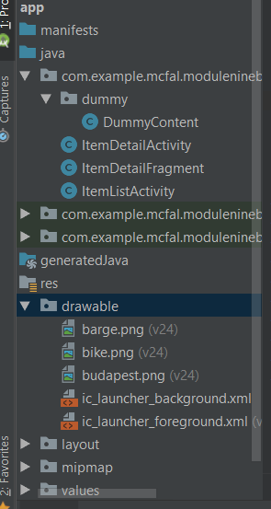

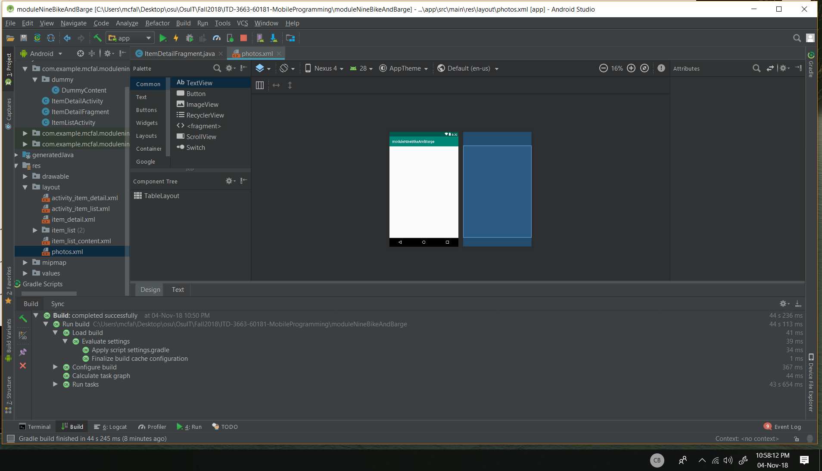

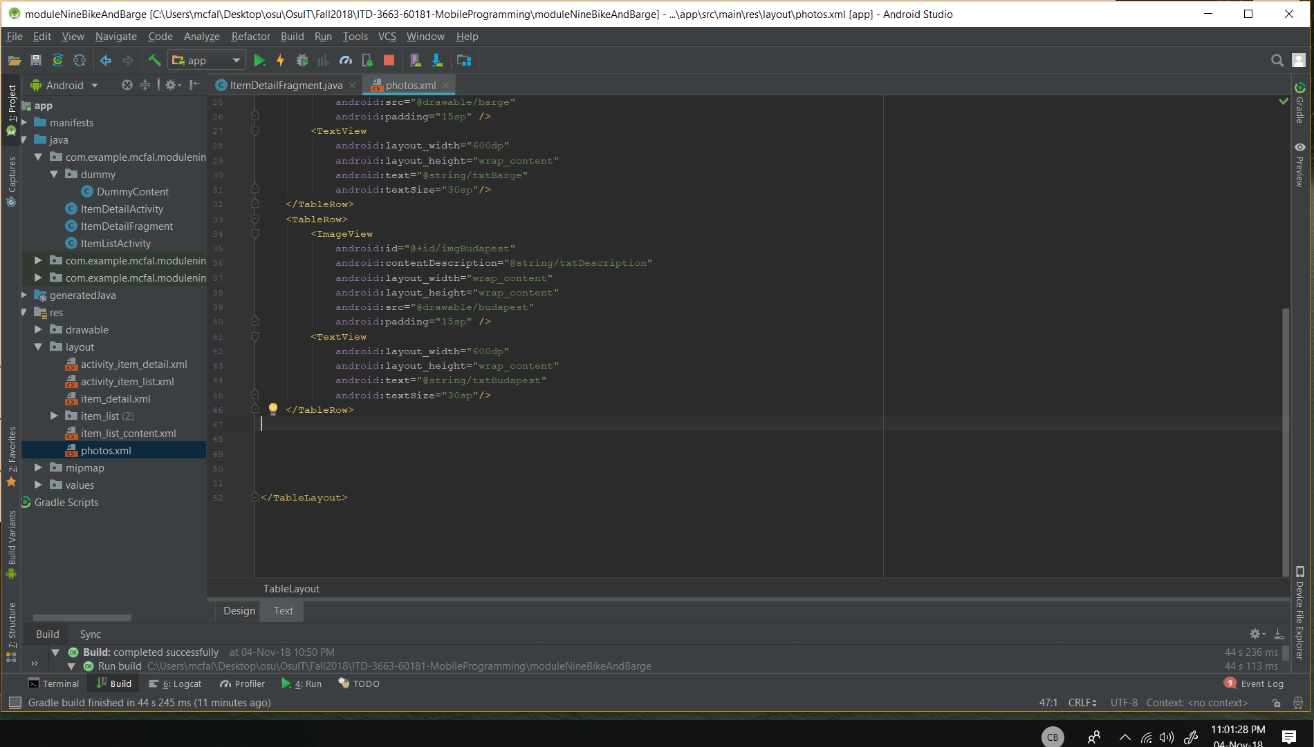

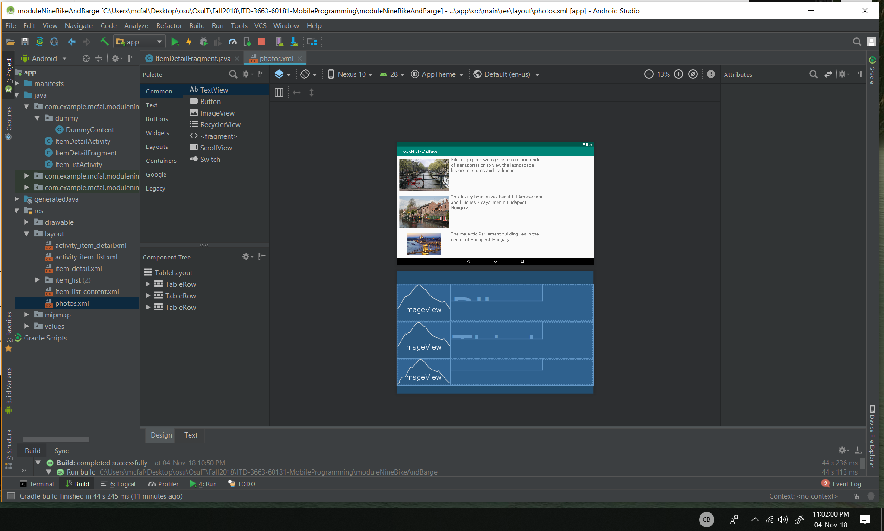

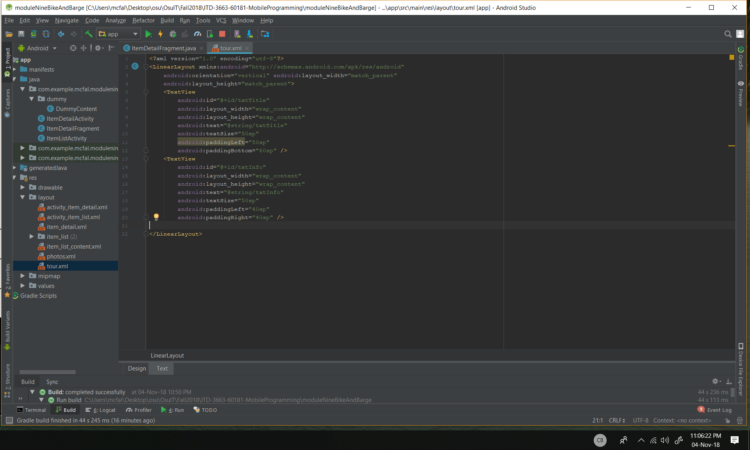

The fragment_item_detail is not available in the layout folder.

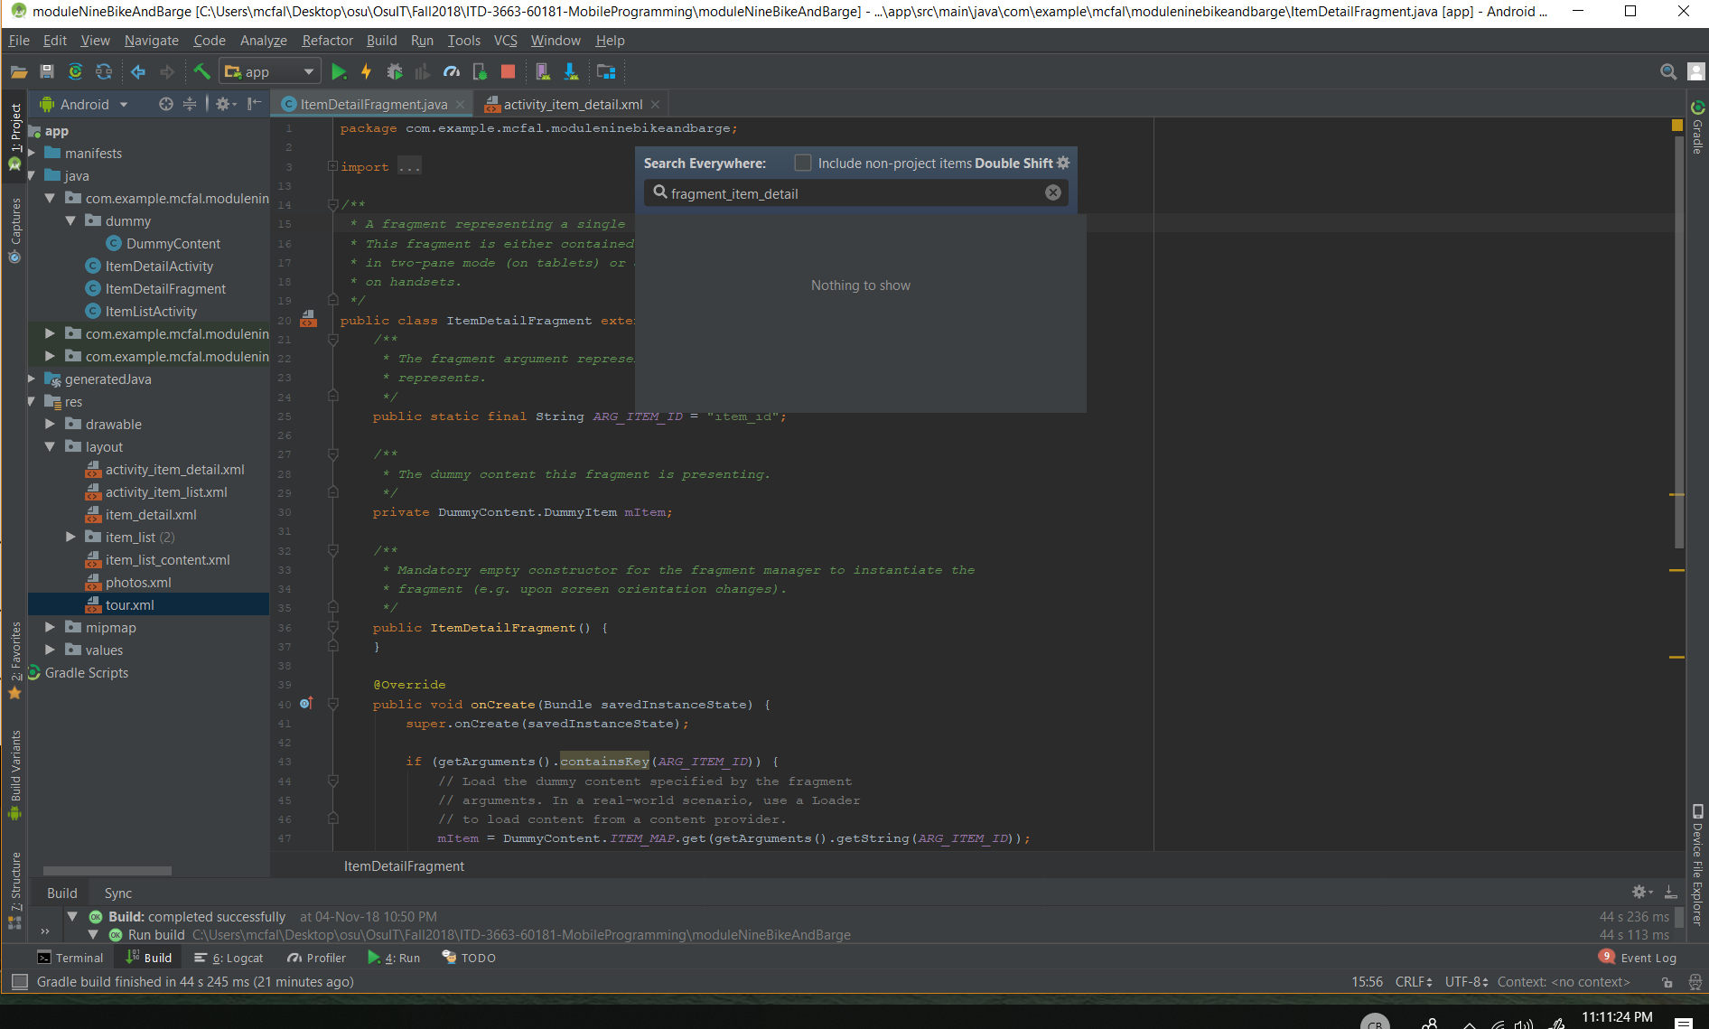

Doesn’t exist, skipping that part

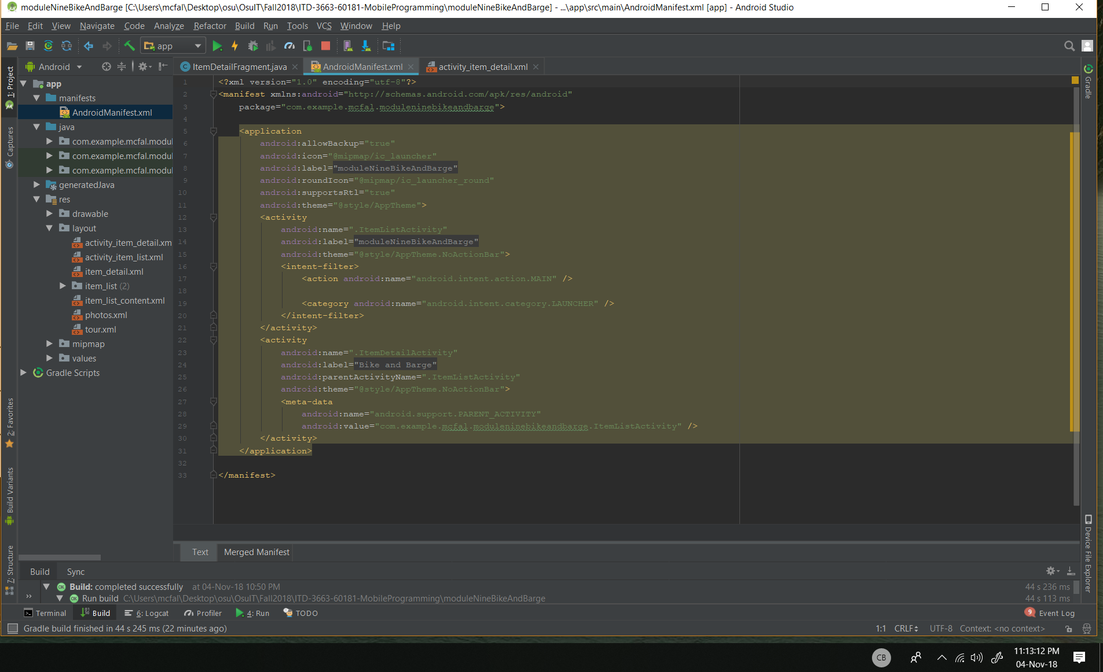

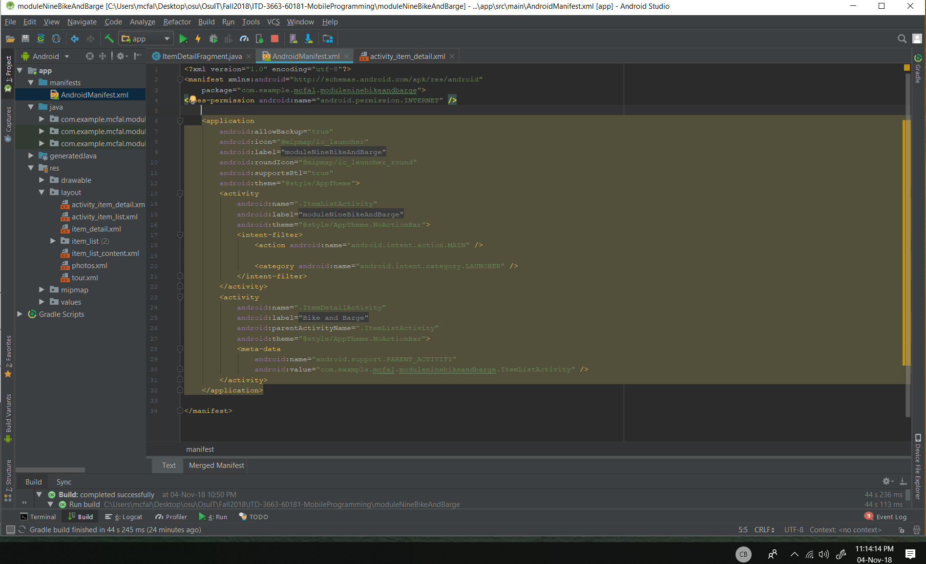

This one’s a bit of a mess. My files don’t look much like the ones in the book.

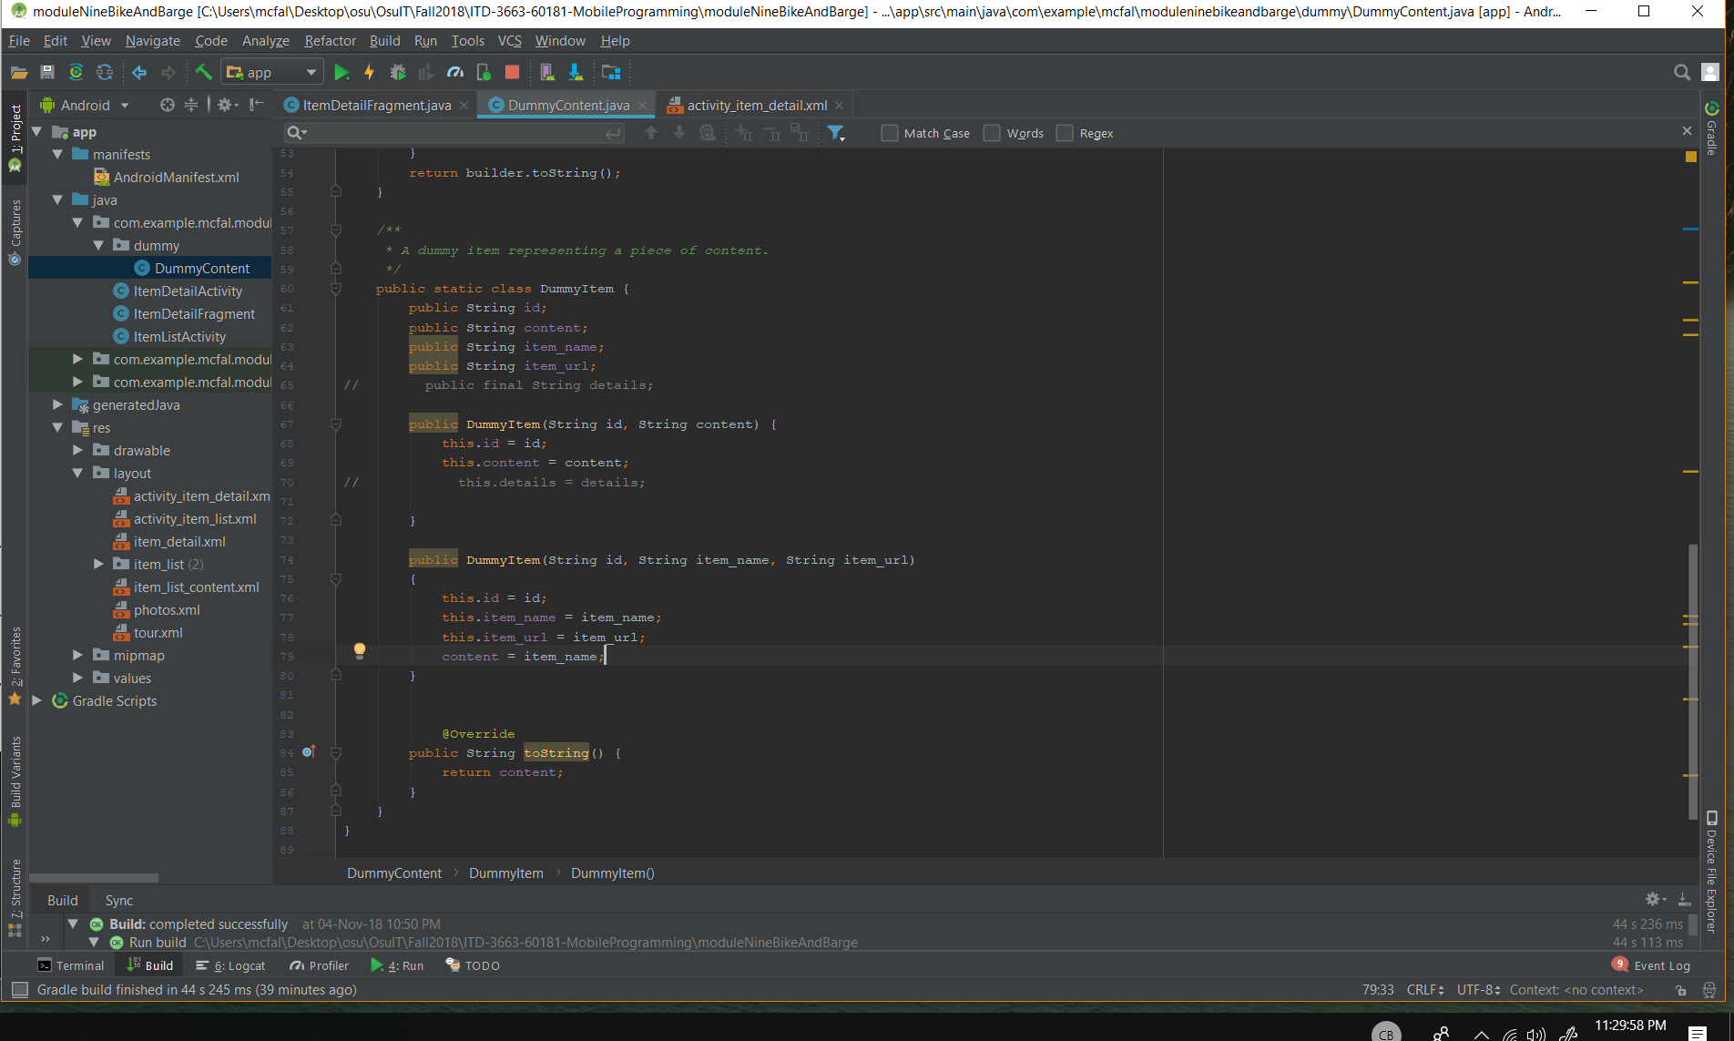

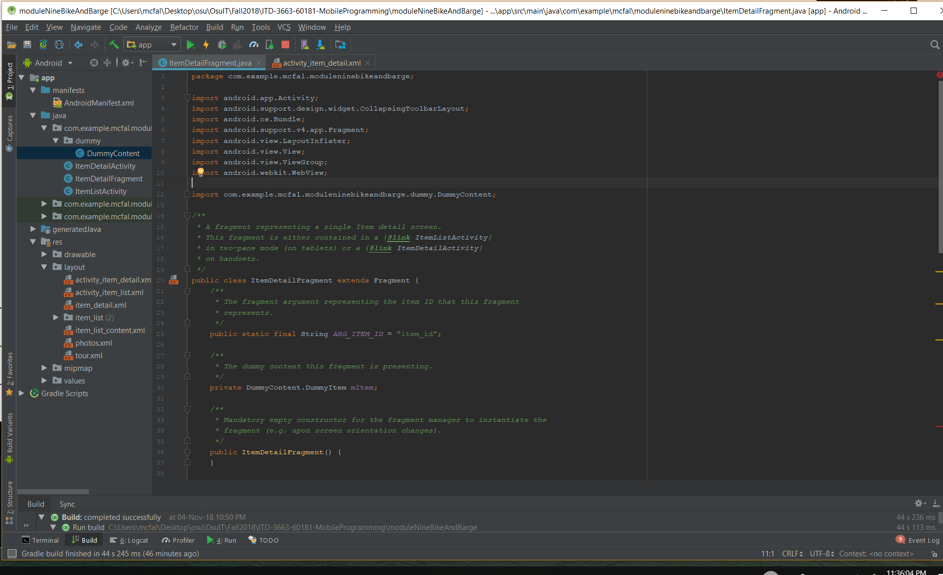

Item three doesn’t work. Casting to a Webview is not appreciated by the application.

